

217, Sheikh Rashid Building

P.O Box 56272, Dubai

United Arab Emirates

Tel: +971 4 2973236 / 04 2974007

Email: uae@verbat.com

TECHNICAL   
PROPOSAL

**Website Development for HAJT**

|  |  |
| --- | --- |
| **Prepared for:**  Hutchison Ajman International Terminal (HAJT) | **Submission Date:**  04 June 2017  **Proposal ID:** WD/04062017/1343/3 |

___________________________________________________________________________________________________________________________________________  
Conﬁdentiality Notice: This Proposal is conﬁdential and contains proprietary information and intellectual property of Verbanet Technologies LLC. Neither this proposal nor any of the information contained herein may be reproduced or disclosed under any circumstances without the express written permission of Verbanet.

© 2017 by Verbanet Technologies LLC. All rights reserved. Confidential.

___________________________________________________________________________________________________________________________________________

|  |  |
| --- | --- |
| Client Information | |
| Project Name | Website Development for HAJT |
| Client Name | Hutchison Ajman International Terminal (HAJT) |
| Client Address | Tender Committee  Hutchison Ajman International Terminals Limited – F.Z.E.  P.O Box 388  Ajman, United Arab Emirates |
| Phone Number | +971 6 7470 111 |
| Fax Number | +971 50 482 3360 |
| Verbat Information | |
| Contact Person | Joyce Daniel |
| Contact Person Phone Number | +971 4 2973236 |
| Contact Person E-Mail | Joyce.daniel@verbat.com |
| Address | PO Box 56272, Dubai |
| Physical Address | Flat 217, Sheik Rasheed Building, Hor Al Anz East, Dubai |
| Project Information | |
| Proposed Technology/Methodology | Dot Net Nuke 9.0.2 |
| Anticipate Start Date | 29 June 2017 |
| Proposal Valid For | 120 Calendar days from the submission of the proposal |

Project Contacts

**Table of Content**

1 Executive Summary 5

1.1 Proposed Solution Model 5

1.2 Solution Objective 6

1.3 Advantages of Proposed Solution 7

1.4 Why Verbat 8

1.5 Key Differentiators 9

1.6 Underlying Support Services 10

2 Functional Specification 11

3 System Architecture 13

4 Functional Architecture 14

5 Hardware Architecture 15

6 Non Functional Requirements 16

7 Assumptions 16

8 Out of Scope 18

9 Technology Solution 19

9.1 Technical Configuration 19

9.1.1 Development Tools 19

9.1.2 Browser Compatibility for Web Admin 19

9.1.3 Hardware Interface 20

10 Delivery Management 20

10.1 Project Management 20

10.2 Roles and Responsibilities 20

10.3 Delivery Activity summary 21

10.4 Project Implementation plan 21

10.5 Deliverables 21

10.6 Estimated Delivery Time for Website Development 22

10.7 Deployment Details 22

10.8 Release Planning 22

10.9 Risk and Contingency planning 23

11 Change Management 24

12 Miscellaneous 25

12.1 Acceptance Criteria 25

12.2 General Terms and Conditions 25

12.3 Assumptions and Dependencies 26

12.4 Source Code & Intellectual Property Rights 27

12.5 Maintenance & Support 27

12.6 Our Clients 29

# Executive Summary

**Hutchison Ajman International Terminals Limited - F.Z.E.** is the port and related services division of **CK Hutchison Holdings Limited (CK Hutchison)**. Hutchison Ports is the world’s leading port investor, developer and operator with a network of port operations in 48 ports spanning 25 countries throughout Asia, the Middle East, Africa, Europe, the Americas and Australasia.

**Hutchison Ajman International Terminals Limited - F.Z.E.** (hereafter referred to as “Client”) has approached **Verbanet Technologies LLC.,** trading as Verbat Technologies (hereafter referred as” Verbat”) to develop a new CMS website that will improve the client’s online presence. The client would also like to use this opportunity to provide their customers pertinent information about their business operations and services.

Website Development is an area where Verbat has in-depth knowledge and expertise. Being the pioneers in Web based and windows based solutions across the major verticals, we are sure to help you enhance your customer engagement to drive differentiation. We bring proven methodologies and processes, global expertise in development, and a legacy of best practices and ready-to-fit frameworks to expedite the development cycle and reduce the total cost of ownership.

Verbat is pleased to have received the request to submit the proposal and values it as a great opportunity to have a long term & mutually beneficial association with the client. Verbat has gone through the requirement and presents a technical proposal for the requested system

## Proposed Solution Model

Stand-Alone Fixed Bid

Verbat will be following a stand –alone fixed bid solution delivery model wherein the required solution would be devised and a suitable pricing would be offered.

## Solution Objective

The client has contacted Verbat Technologies to develop a new Content Management System based web site using the latest technologies and design trends. The new website shall have the following features

1. New & advanced interactive design
2. Website shall provide information about HAJT business, products and services.
3. User shall be able to perform business activities ex. E-Services, E-Customs etc.
4. New web site shall meet design guidelines of HPH (Parent) website.

The scope of the system includes:

* Study, Design, Development & implementation of the CMS based Web site
* QA & UAT
* Application documentation (Wireframes, Requirements, Specifications & Test Cases)

.

**The main features of the Website are listed below:**

* Admin module to add and manage users, add roles, authenticate and authorize users etc.
* HAJT work culture, apply for jobs and application success emails
* Different types of downloadable forms along with information on supporting documents to fulfill the request.
* Berthing request Workflow
* Gate Pass Request workflow
* General site pages with updatable content
* Searchable site with advanced search features
* Fully responsive site
* SSL certified and encrypted site
* Data and application backups

Verbat’s Solution architects have conducted a thorough research on the requirements and have come to the conclusion that our proposed solution, which is detailed further in this document, will meet the requirements put forth by the client. And the proposed solution will be delivered in a phased approach as per Verbat‘s managed solution model.

**Strong and Scalable platform:** The platform proposed will be strong and scalable enough to accommodate future enhancements.

**Accelerated solution:** The framework would act as a solution accelerator. It would provide the basic building blocks which could be reused in future for building new components and features as part of enhancements

**High performance:** The light weight framework used consumes fewer system resources thereby making the application perform faster

* System shall be available 24/7
* System shall be performant without any lags or delays

**Security:** The application will be developed considering various aspects of security

## Advantages of Proposed Solution

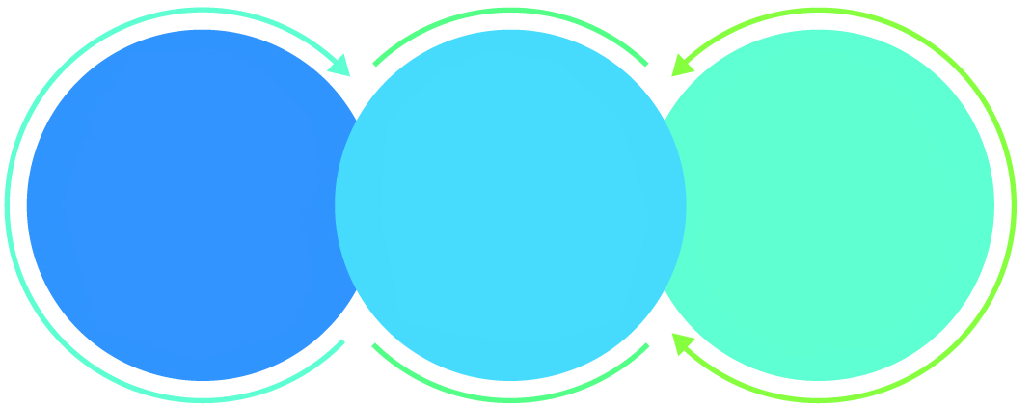

01

Agile development offering reliable, scalable and secure solution

02

Smooth transition and quicker completion of processes

03

User friendly interfaces enabling easy navigation between screens

## Why Verbat

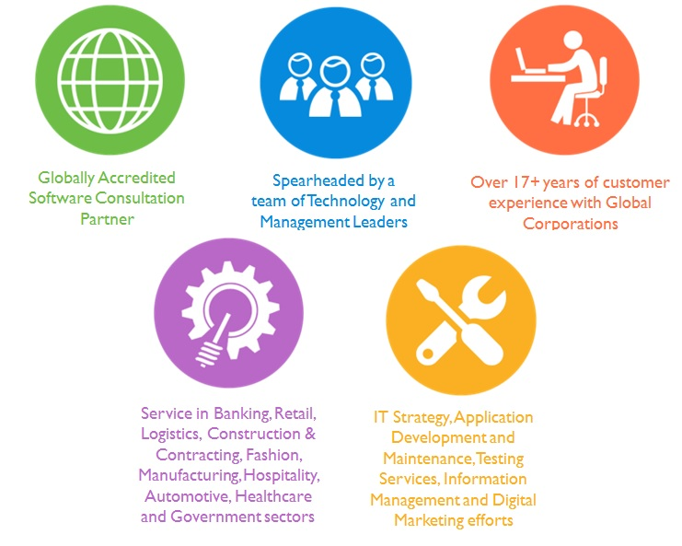

## Key Differentiators

Delivered digital transformation expertise to global customers for over a decade by following industry best practices to maximize ROI for client

Keen technology intelligence combined with aggressive market research to deliver solutions that achieve results with measurable value

Enable access to global consulting expertise with strong local market and business knowledge

Commercial Model that is customizable for your business needs

Services that are designed to optimize applications for improved performance and overall efficiency

1,000,000 plus man-hours of expertise in technology frameworks spanning Microsoft, Open Source, mobility platforms and other proprietary IT technology

Partners top technology vendors to bring in the latest and best services in integration, collaboration, and development

Commercial Model that is customizable for your business needs

Proven Methodologies & Processes

Investment in R & D

Strong Local Presence

Flexible commercial Models

Technology Associations

Software Development Experience

Offshore Development Centre

Quality Assurance & Testing

## Underlying Support Services

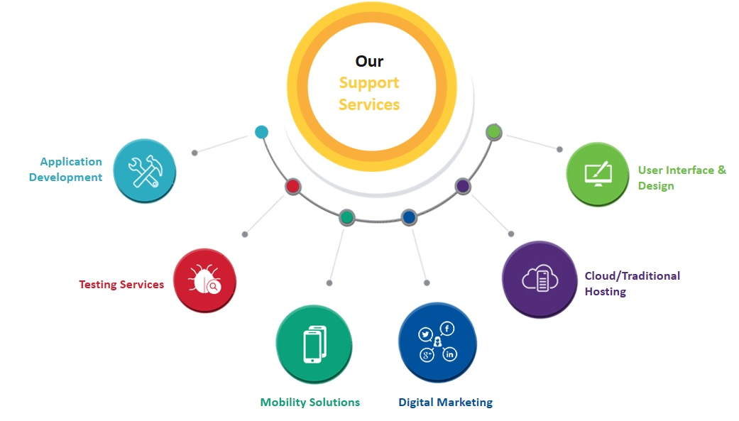

# Functional Specification

To develop the CMS based web application, Verbat proposes that the application be **developed in a single phase**. Functional specs for the application is detailed below.

|  |  |  |
| --- | --- | --- |
| **Admin** | **Compliance** | |
|  | **Yes** | **No (Alternative)** |
| User Management ( add users, reset passwords, reminder emails etc.) and Roles (copy editors, publishers) | X |  |
| Authentication & Authorization | X |  |
| Configure Multilanguage ( Arabic, English and Chinese) | X |  |
| Update container tracking | X |  |
| Generate reports for Admin user in CSV format | X |  |
| Approve Berthing (place holder for intended user) | X |  |
| Approve Gate pass (place holder for intended user) | X |  |
| **CMS Features** |  |  |
| Assign workflow permissions to different roles | X |  |
| Easy to implement archival / retrieval of content | Basic | X |
| Support the generation, recording, printing, and display of reports for internal users | X |  |
| Automatic backup and restore of application | X |  |
| Automatic backup and restore of database | X |  |
| **HAJT Work Culture** |  |  |
| Job application form with resume attachment and success or failure message in processing the request | X |  |
| Auto generated emails to notify users of a successful job submission | X |  |
| Auto generated emails to applicant upon receiving job application | X |  |
| Information on HAJT Work Culture | X |  |
| Enable users to access published information, content, link to group website, external ministries and internal HAJT Services. | X |  |
| **Downloadable forms** |  |  |
| Forms should be downloadable with information on supporting documents to fulfill the request | X |  |
| Request letter for hot work permit | X |  |
| Request letter for repairs work (Cold work). | X |  |
| Maintain trainee records on performance | X |  |
| Request letter for Driving permission. | X |  |
| Request letter for Sanitation certificate. | X |  |
| Users will receive e-invoices via e-mail | X |  |
| Users should be able to download e-invoices in PDF format | X |  |
| Download or request complete pricing list i.e. Tariff, Customs duties, other charges and service standards. | X |  |
| **Berthing Request Work Flow** |  |  |
| Request berthing with option to save and edit form before form submission | X |  |
| Submit Berthing request with required documents (may be mandatory or optional) | X |  |
| Notify users upon successful submission | X |  |
| Approval hierarchy to accept or reject the request | X |  |
| Notify users upon approval or rejection immediately or via emails with steps to be taken | X |  |
| Downloadable approved berthing requests | X |  |
| **Gate pass request workflow** |  |  |
| Fill gate pass request form with option to save and resume | X |  |
| Submit gate pass request form with required documents | X |  |
| Notify users upon successful submission | X |  |
| Approval hierarchy to accept or reject the request | X |  |
| Notify users upon approval or rejection immediately or via emails with steps to be taken | X |  |
| Downloadable approved gate pass requests | X |  |
| **Site pages** |  |  |
| Contact Us, Business services and procedures | X |  |
| Updatable Press release page | X |  |
| Updatable Service pages | X |  |
| Updatable Announcement pages | X |  |
| Updatable Affiliate Organizations page, links to HAJT group of companies, external ministries and internal services such as HAJT e-customs and e-services | X |  |
| Updatable News page | X |  |
| Updatable page with audio and video streaming services | X |  |
| Searchable site with basic and advanced search. Full text search in Arabic, English & Chinese. | X |  |
| Simple and advanced search for container tracking. | X |  |
| Registration / Login page for users | X |  |
| **System Features** |  |  |
| The website shall have Redirection mechanisms between sites and returning to previous pages | X |  |
| The system should run on the latest versions of all browsers and mobile application. | X |  |
| Secure & encrypted site | X |  |
| MD5 for password salting using core .net libraries (by default MD5 is 128 bit encryption) | X |  |
| Audit trail for all user actions (in sequential order) | X |  |
| Configurable application logs (info, warning, errors) | X |  |
| 2 Major UAE payment gateways (8 hrs. additional effort for each additional gateway support) | X |  |
| SSL encryption (Will implement if client procures SSL) |  | X |
| Support screen resolutions (800*600, 1024*768 and 1280*1024) | X |  |

# System Architecture

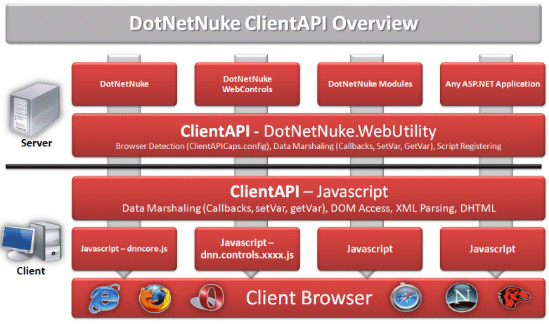

DotNetNuke supports plugging design. Each function is implemented in a module model, which enables easy plug in and plug out. This is especially suitable for enterprise application integrations.

DotNetNuke has lucid framework and highly standard coding convention. It can unify different coding styles and enhance the code quality and project maintainability. In consequence, when a developer leaves the project, it will not take long for his successor to take over the project.

**Development Methodology**

Verbat works with the client using agile development in this project. Business analysts are responsible for writing stories. Every story describes an independent function, then our development team would design and develop DotNetNuke module according to associated story.

Open Project is used to record the stories, changing requirement and bugs in client's side, and Verbat team would take the tasks from the Open Project to do development and bug-fixing work.

Verbat's team will often provide valuable suggestions on agile management, improving process, problem solution, third party tools and design solution. Our powerful ability and diligent work attained the recognition.

# Functional Architecture

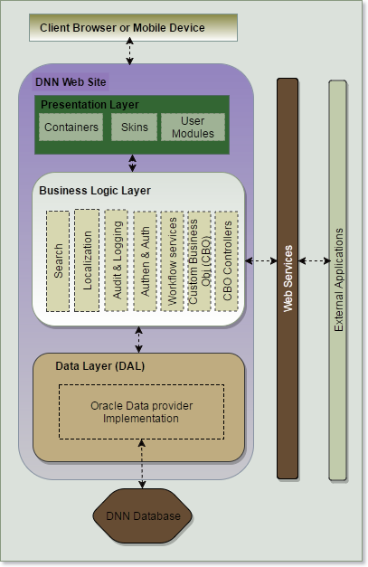

1. System incorporates an option to customize the skin (look & feel) as well as provide essential functions such as Search and workflow services to manage the application
2. The application database will be hosted on an Oracle box. As explained in the previous section, DNN works with Oracle databases using the default ADO.net* provider for Oracle, but there may be limitations when employing third party modules
3. Web services can be integrated to future proof the application so that it can interact with other applications
4. A three tiered application architecture based on the MVC framework will be used for application development

# Hardware Architecture

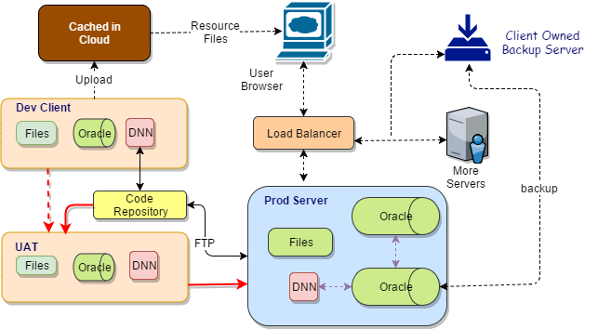

The hardware architecture makes provision for the following

1. Backup and archival for Database and Application data.
2. Load balancers will be used to make sure that the load distribution of the application is evenly spread
3. Application code will be stored in well-known code repositories (GIT or TFS)

**Note on Archiving**: Our archival process depends on the archival capability provided by the DotNetNuke. This proposal does not include advanced backup solutions. See assumptions and out of scope for details. **However**, if the client has full control of its production server, Verbat will provide a secure backup solution that will incorporate both hardware and software elements. The implementation details are outside the scope of this proposal and it entirely depends on the level of sophistication required by the client. A simple backup plan on the other hand may not cost any additional charges.

# Content Workflow

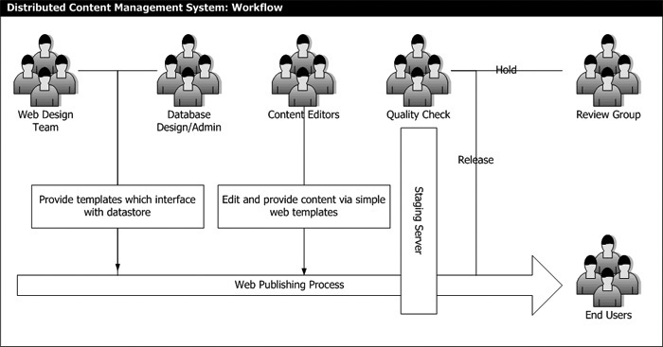

The web design team along with the clients develop the templates for publishing content. Content editors from the client’s team use these templates to create content. The content is checked for quality and reviewed by the management. Once the content is approved by the management it is published and available for the site users.

The Web content publishing workflow is configurable, such that different roles can be created. Workflows can be created so that the content to be published is arbitrated until it is ready to be published. In the example it consist of three levels of approval, however this can be configured to fit the client’s needs, since DNN supports this functionality inherently.

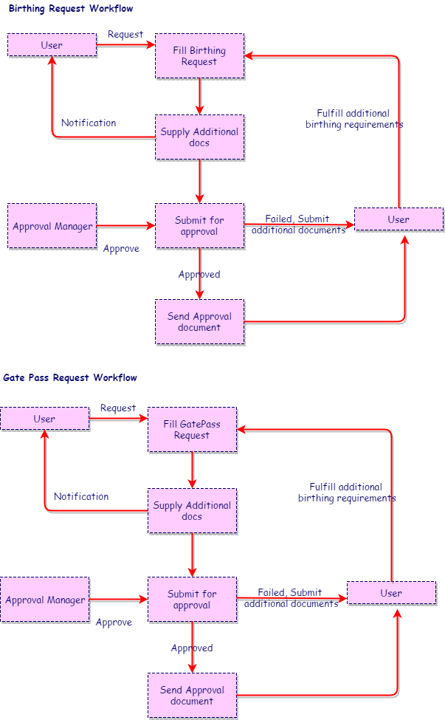

As per the requirements, approval workflow for “Gate pass” and “Birthing” request are similar. However the proposed application considers the two roles to be different. Hence the approval manager roles may be assumed by two different entities. The proposed application considers only one level in the approval hierarchy. These roles have no relationship to the roles defined by the publisher workflows. The super admin creates these roles and users are assigned to these roles by the super admin. The design allows for configuring the workflow to accommodate more than one level of approval hierarchy.

Job Applicants may register on the site and they can upload their resumes. The resume workflow incorporated is trivial. This means that it will not have functionality similar to a full-fledged job portal. However basic features such as search, email notification to candidates and HR may be incorporated.

E-invoicing is based on the assumption that it relates to electronic payments remitted via the portal. A copy of all transactions conducted via the portal will be saved for future reference.

Multi-lingual functionality uses different tables for storing the text for additional languages.

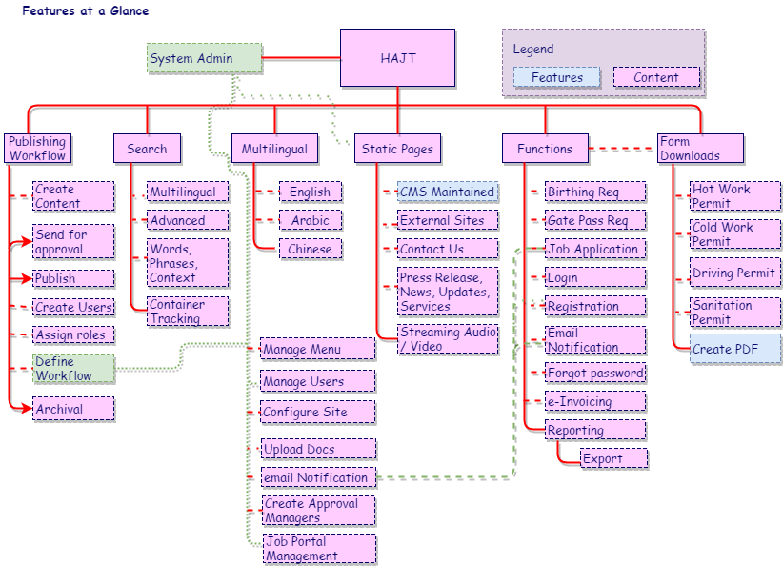

# Non Functional Requirements

|  |  |
| --- | --- |
| **Requirement** | **Details** |
| User Experience and  UI Design | * The website will be developed only in English, Arabic and Chinese * The layout and graphical components will be created considering the usability factors |
| Performance | * Website will allow users to have smooth and quick access to the information or services they require. |
| Security | * The system will be protected against attempts of security breaching that may arise. * Web security standards will be followed. |

# Assumptions

The project solution and technology is created from the initial understanding of the requirement shared with Verbat through mails and meetings. The proposed solution is based on the following assumptions:

1. Objective:

To develop a CMS based Website with the functionalities as defined in the “Functional Specifications” section.

1. Design:

* Client to provide Verbat with the branding guidelines.
* The proposed Website front end and backend would be developed in English, Arabic, and Chinese.
* Verbat is free to use custom made template for design, if required.
* Client shall provide licensed images and logos in specified size & format

1. Development:

* Requirements should be well defined, agreed and signed-off by the client
* Client will provide sample data to test the entire Website
* Internet connectivity is required for the functioning of the website.
* Color theme shall be provided by the client
* Client shall provide licensed images and logos in specified size & format
* Client shall provide the text and associated images for languages other than English
* Client shall purchase SSL certificates
* Client shall purchase the professional or enterprise grade edition of DNN for advanced workflows
* Application and data backups are subject to the purchase of such services at an extra cost
* Client will purchase a search plugin if not available with the standard distribution
* Client will host and manage the application on infrastructure recommended by Verbat for managing database and application backup
* Downloadable forms shall be provided by the client
* *The .NET Framework Data Provider for Oracle provides access to an Oracledatabase using the Oracle Call Interface (OCI) as provided by Oracle Client software. The functionality of the data provider is designed to be similar to that of the .NET Framework data providers for SQL Server, OLE DB, and ODBC. (MSDN: Mar 30, 2017)
* Plugins or language pack for Chinese language functionality may be needed
* Plugins for archival will need to be purchased. DNN does not support advanced archival features

# Out of Scope

With the ever evolving digital market, the requirement needs should be clear to both the parties involved, hence the importance of mentioning the out of scope details of the project. Following are considered to be out of scope while creating this proposal.

* Purchase of images, fonts
* Adding new features to the application other than mentioned in this proposal
* Any language other than English, Arabic & Chinese
* Integration with any third party system including payment/ SMS gateway and Clients Internal Systems
* Manual data entry
* Database migration
* Content writing
* Audit Trail
* Annual Maintenance Contract (Bug fixing, debugging) – Please refer section 12 titled as “Change Management”.
* ~~Software packaging~~
* Physical deployment at client’s site
* Workflow other than Gatepass and Berthing
* Content or image procurement or uploading or editing
* Hosting Infrastructure and Maintenance
* Hardware Integrations / procurement and purchase
* Backup solution and Disaster recovery.
* Data Replication
* Does not provide features to post jobs or process job applications
* E-Invoicing using third party integrations
* Software or hardware based archival strategies outside the scope of CMS not supported. Verbat will provide archival functionality to the extend allowed by DNN. Do not confuse this with a disaster recovery plan.
* LDAP sign-on is not within the scope of this proposal

# Technology Solution

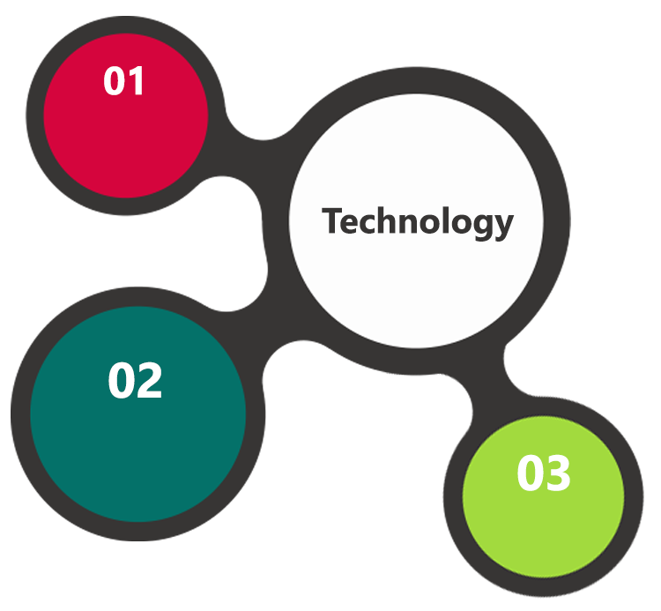

ASP.Net 4.5

MVC, C#

DNN 9.0.2

Oracle 11g  
Windows 2012 OS

SSL

HTML 5  
JavaScript  
CSS3

A major portion of the application will be developed using Microsoft technology employing a mix of web services and web interfaces to configure the application.

## Technical Configuration

### Development Tools

* Visual Studio
* Server Management Studio & Photoshop
* DNN CMS framework (9.0.2)

### Browser Compatibility for Web Admin

* Chrome 56.0
* Firefox 51.0
* Internet Explorer 11

### Hardware Interface

The application is reliant on hardware interfaces to provide a seamless automated user experience.

* Computer with Windows 8 or 10 OS
* Load Balancer
* Oracle Server

# Delivery Management

## Project Management

The Verbat development center strictly follows industry standards on quality. The project management is process governed by the Verbat Quality Management system and is put to verification through internal audit programs that happen from time to time.

Verbat will dedicate a project manager for the proposed implementation. Verbat proposes Client to identify one project manager who will be driving activities to be undertaken by Client to be the single point of contact for Verbat.

Verbat is a community of strong Agile practitioners. We follow the scrum methodology for project management and delivery. Verbat recommends clients to procure a JIRA license for the duration of the project. This will enhance and facilitate smooth communication for both parties. More importantly clients will be able to track the progress of the project on a daily basis.

In addition to this Verbat will communicate with the client on a daily basis the progress of the project along with perceived bottlenecks. We also conduct standup meetings on a daily basis with the project stakeholders. We strongly believe in effective communication so as to keep our clients abreast on every aspect of the project progress. Hence we are willing to accommodate any other additional effort that would alleviate the comfort level of our clients. Weekly and monthly status meetings and mails along with definition of done are assumed by default.

## Roles and Responsibilities

Verbat will assign a dedicated Project Manager/Project Lead to lead the project, who will be the first point contact for Client. He/she will be responsible for planning and managing the various activities within the project. He/she will work closely with Client Project Manager, to give periodic status updates and ensure high level of visibility and comfort on the progress of the project.

The Project Manager/Project Lead will lead the co-ordination between Verbat and Client, thus enabling smooth transitioning of Client requirements to the Verbat’s offshore delivery team, and provide visibility as well as comfort on the progress of the services to Client.

He/she will have periodic meetings with Verbat’s Senior Management, thus ensuring Verbat’s Management commitment and focus on Client initiatives.

## Delivery Activity summary

|  |  |
| --- | --- |
| Activities | Description |
| Detailed requirement Analysis | Verbat team to conduct detailed study of requirement for the phase. If clarification is required, team will reach out to Client for more information and/or time for discussions. |
| DB Design | DB design for central and test DB. |
| Software Requirement Specification document (SRS) | Once the requirement analysis is completed, Verbat team will submit the SRS document for approval |
| UI/UX Design, Prototyping | Based on the SRS, Verbat UX/UI team will work on the UI/UX of the screens and submit a prototype for approval |
| Functional Specification Document (FS) | Once the Prototype. UI/UX is approved, Verbat shall submit an FS document for approval. |
| Development | Actual system development starts based on the FS. This involves detailed design and software development of Web Application. |
| Testing | Test Planning, test plan creations, internal, integration testing and user acceptance testing. |
| Deployment | Deploying the latest built in the Verbat Test Server. |

## Project Implementation plan

Verbat will be providing the solution in a fixed bid approach which ensures minimum viable solution for quick wins with core focus on the long term business objective and outcome. Once the implementation is over, Verbat will initiate the application maintenance process which continues to extend after the implementation.

## Deliverables

* Software Requirement Specification Document (SRS)
* Prototype of the Website
* Functional Specification Document (FS)
* Fully Developed & Tested Website
* One time training activity

## Estimated Delivery Time for Website Development

The effort estimated for delivering the application as specified in section 2 will be as below:

**Project Initiation by Last week of June**

**UAE working days for the prototype from the date of approval of the project (LPO/Signed Proposal) with Advance Payment and Working days for the development of the application from the Date of Approval of the Prototype.**

| **Activity** |
| --- |
| Contract Signoff (T0) |
| Project Initiation & Initiating requirement gathering |
| Software Requirement Specification Document(SRS) |
| SRS Approval (T1) |
| System Prototype-Complete |
| System Prototype-Approval (T2) |
| Functional Specification (FS) |
| FS Approval(T3) |
| Development Phase-Complete |
| Perform QC (Unit Testing and Integration Testing ) |
| System ready for UAT |
| UAT Acceptance (T4) |
| Release of the application with source code to client(T5) |

## Deployment Details

* Client can opt for hosting the application at Verbat’s Server.
* If deployment is at the client’s server, responsibility of deploying the application onto the production environment after conducting the necessary acceptance testing will lie with the client unless and until Verbat’s support is contracted for deployment.

***Note****: Hosting the application at Verbat’s server will call in for additional charges.*

## Release Planning

* Client will be informed about the release date and time through email.
* Client performs the UAT

## Risk and Contingency planning

Verbat has identified various risk factors associated with this assignment and understands the impact of these risk factors on the project schedules. The objective of this section is to highlight for both Verbat and client, the risk factors, to analyze the impact of the risks on project execution, and to propose strategies to control and reduce the impact of the risk factor

These various risks, which could arise during the project, are tabulated below along with mitigation implementation.

| Type of risk | Impact | Risk Mitigation | Risk Handling |
| --- | --- | --- | --- |
| Scope Creep | H | Functions and features will be detailed in system requirement documents and will go through client approval. Once this document is approved, any change to requirement will go through change management review for possible impact assessment. | Proper change management procedure will be implemented. |
| Delay in customer feedback | H | The plan is prepared with enough lead-time for customer reviews and approvals.  The customer is indicated with the dates when the document is expected after review and approval. | The request for feedback will be escalated if not attended at the right time so that the schedules are not affected. Deemed acceptance criterion is set up front and will be followed. |
| Non-availability of necessary software’s, frameworks, database instances and infrastructure at client’s hosting environment(If hosting support is provided by Verbat) | M | Client will be informed in advance on these requirements. | Possible impact to schedule. |
| Manpower attrition | L | All efforts would be made to ensure process dependence rather than being person dependent. As a risk mitigation plan Verbat will train backups. | A new person will be identified as early as possible, provided the required project-specific training and mentored by the senior members of the team to minimise impact of attrition on the project. |

*H-High, M-Medium, L-Low, NA-Not Applicable*

# Change Management

Any addition which comes out of the project scope, upon and after the launch of the tool will be considered as change management. Verbat recommends the following change management procedure for the same.

* Any change which comes out of the project scope, which was discussed, documented, and mutually approved by both the parties in the requirement stage, will be carried out only through raising a change request.
* Change request will be studied and an impact analysis on the existing work flow will be performed.
* On finalizing the impact, effort estimation for the change will be calculated and raised as additional requirement.
* Verbat will initiate the change request only after getting a formal approval from the client for the additional changes raised.
* Any change from the scope will be charged at **AED 1200 per man day effort** and approval from the clients will be availed before commencing on any change management.

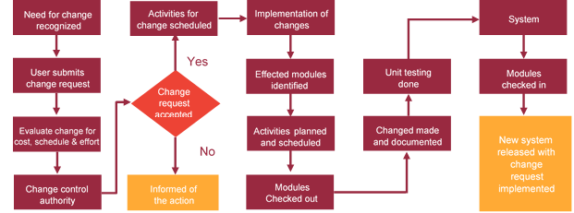

# Miscellaneous

## Acceptance Criteria

* UAT sign off should happen within 14 Days on release of the website and the acceptance confirmation needs to be mailed to Verbat failing which Verbat will consider the project as approved by the client.
* Any comments or reason for rejection need to be documented and the same needs to be sent as an email from the official mail id of client to Verbat.

## Warranty

* Verbat shall provide a bug ﬁx warranty at no additional cost for 30 days from the date of acceptance of the project, for correction of any errors in the developed application that may be attributed to Verbat.
* However, this does not cover modifications by Client, or use of the application on an environment other than the proposed environment, or other circumstances outside Verbat’s reasonable control. In such a case Verbat reserves the right to charge for its services.
* All error corrections will be executed at Verbat India office. In the event of any need for on-site work, all expenses incurred for such trips will be payable to Verbat by Client.

## General Terms and Conditions

* An average of 20 working days are assumed in a month
* All the projects activities will be carried out from our off-shore development center in India
* The scope of the project is to develop the Application as detailed in the scope of the project and mentioned in this proposal. Any changes or additions will have to go through change management.
* This proposal and all technical/ functional specifications have been derived or concluded from the data shared via email / information's transferred during the initial requirement analysis meetings and conversations. Verbat reserves the right to amend the terms of this proposal, should the SOW terms, functional features and functionalities change during the course of the project
* Application will be best viewed only in the environment mentioned in the section 9.1.2
* All the documentation will be provided in English.
* Third party components may be used to develop this application.
* All Source Code and other project artefacts would adhere to the Verbat document templates and internal coding standards
* Acceptance criteria shall be based on the clauses which were mutually discussed between Verbat and client at the Requirement Analysis phase and the same will be documented and approved by both parties through official emails
* In case Client requires any extension of the proposed acceptance schedule, the associated effort and cost of such extension can be mutually reviewed.
* For any circumstances if project needs to be put on Hold / Stop it requires minimum request notice period of 1 week along with duration for which request will be addressed by management and final decision on the request will be based on that
* If deployment is done in client’s server, Verbat cannot be held responsible for any performance issues arising due to hardware malfunctions.
* Client is responsible for data backup in case the application is not hosted on Verbat server.
* Source code will only be delivered or uploaded on the Production Server once the due payments are made.
* This proposal would have been derived or concluded from either the RFQ /RFP/data shared via email / information transferred during an initial requirement analysis meeting /tele-conversation. Verbat Technologies reserves the right to change the terms of this proposal as the final terms (including the costing), features & functionalities could change during the course of the project. Hence any fees quoted in this proposal may not be considered as the final cost of the project unless agreed and signed by both parties.

## Assumptions and Dependencies

* Detailed system study is required before the start of the project.
* During the requirement gathering phase, authorized personnel from the Client’s side is expected to be available for discussion and finalizing the HLD (High Level Design), before development commences.
* Type of reports and formats, if under the scope of the project, needs to be specified by Client before project sign off.
* Workflows if under the scope of the project, need to be specified/ confirmed by client before project signoff.
* All queries regarding the client requirement and any queries which may hinder the project advancement at any stage should be answered by the client within 24 hours from the time of initiation, failing which the time delay will get added to the actual effort which was estimated.
* Verbat assumes that all sign-offs from Client will be provided within agreed and specified timeframe.
* Client will provide all the necessary contents, both text and image, before starting the project in the format suggested by Verbat (if any).
* The client should provide the relevant information and data well in time for the execution of a related activity. Non- availability of this information or data may lead to an interruption of work which may result in a delay in delivery as well as additional costs to the client.
* Client should have/possess server with technical specifications as suggested by Verbat for the proposed application.

## Source Code & Intellectual Property Rights

* Upon completion of the Project and 100% completion of the payment, client will have access to the source code except for propriety codes, developer tools and third party application / modules like Microsoft Dynamics Products, Share Point LMS etc.
* The solution offered will be the intellectual property of the client and will be made available to the client on an “unlimited license” basis.
* Modifications by third party/person: No person or organization, other than Verbat or any person authorized by Verbat in writing, has any permission to modify/change the software Solution to be eligible to get continued support from Verbat as per the support terms defined under this document.
* Liabilities/Damages: Verbat accepts no liability or damages of any kind arising out of use or non-use of the software delivered. The responsibility of testing of software lies with Client.

## Maintenance & Support

Maintenance contracts by default are supported as per the basic SLA terms.

**AMC with Basic SLA is charged at 20 % of the total project value**. Additional Effort/change management request will be added towards Total Value of the Project to determine the AMC value.

Maintenance support is limited to providing application support for ensuring the consistency of the look-and-feel, bug fixes and user issues i.e. maintenance and support of the existing features of the application.

Support does not in any way cover providing technical or other support to the end users. The maintenance agreement does not include functionality changes or feature additions which are handled as change requests which will be charged AED 1200 per man day. AMC does not include server support, maintenance and application deployment.

AMC charges will cover Off-Site Support and Debugging. Support includes E-mail, Telephone and Chat unless explicitly specified. In the event, the application is hosted with the client; necessary remote desktop connectivity should be provided for carrying out maintenance activity.

Gap in AMC - In case if the client does not opt an AMC for a year and want to renew it after that period, 50% of the AMC amount for the year for which AMC is not taken will also be payable if the client wishes to renew the AMC contract.

Note:

* Please note that the AMC support shall start only after all the necessary sign-offs (AMC Document) to this effect have been given.
* It is not mandatory that the client should opt for an AMC. The client will still be supported on an ad-hoc basis on an agreed man-day rate.
* AMC Payment Terms: 100% to be paid as advance.

Service Level Agreement

|  |  |  |  |
| --- | --- | --- | --- |
| Key | Max Response Time | Max Resolution Time | Target |
| Basic | 1  working day | 3 working days | Request / incident / problem tickets. |
| Advanced | 5 Business Hours | 12 Business Hours | Request / incident / problem tickets. |
| Priority | 3 Business Hours | 5 Business Hours | Request / incident / problem tickets. |

Note:-

* We provide Basic SLA as standard with AMC while Advanced and Priority SLAs attract additional charges.
* Time zone applicable as per UAE time zones (4.00 AM GMT to 1.00 PM GMT- Sunday to Thursday).

## Our Clients

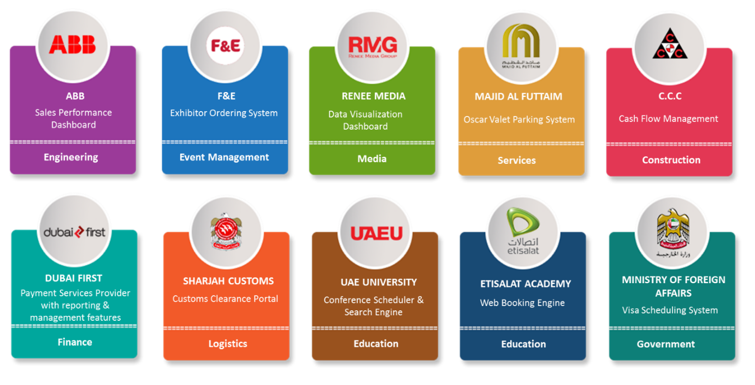

We look forward to hearing from you soon and hope that you will give us the privilege to work with you in meeting your business goals. Thank you.

Thank You



©   
1999 - 2017. All Rights Reserved   
Verbanet Technologies LLC  
www.verbat.com